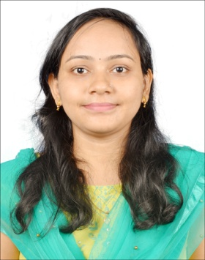**PERSONAL BIO-DATA**

**Name:** Rasmita Prusty

**Present Designation:** Guest faculty in Geology

**Address**: Bheda ,Cuttack-754290

**Date of Birth**:09.02.1996

**Date of Entry into Govt.Service**: 11.09.2019

**Mob No:**7809931675

**E-Mail :** [rasmi.prusty1995@gmail.com](mailto:rasmi.prusty1995@gmail.com)

### Carrier Objective: A strong motivation skill along with strong desire to work in the organization that matches my profile by constant learning and implementing. Looking forward for challenging career in the "geological” field to prove myself with continuous hard work in the provided area of development.

**Academic Records:** **M.Sc** in Applied Geology from Sambalpur university,Burla in 2017

**M.Phil** in Applied Geology from Sambalpur university,Burla in 2019

**Area of Specialisation**:M.Phil –Sedimentology

**Achievements**: 1.Secured All India rank of 174 in Geology paper of Joint Admission Test for M.Sc (JAM) 2015 among 2000 students.

2.P.G Scholarship (Institute of Mathematics & Application)**Computer Proficiency**: PGDCA

**Skills**: Technical – Arc GIS,COREL DRAW

Soft Skills-Adaptability ,Time management ,Teaching

Language Skills-Odia ,Hindi,English

Geological Tools-GPS,Brunton and Petrological Microscope

***FIELD TOUR:*** 1. KATEIBIRA WATERFALL AND IB RIVER (2012-13).

2 .LAKHIMUNDA AND BRAHMANI CAVES (2013-14).

3.LANJIBERNA OPENCAST MINES AND HIRAKUD DAM(2014-15).

4. MAHANADI RIVER BANK (2015-16).

5.JADUGUDA URANIUM MINES(206-17).

6. KANIKA AREA,LOWER GONDWANA (2017-18).

**Extracurricular Activites**:1.Red Cross(2007-2009)

2.National Service Scheme-NSS(2012-2014)

**Research Publications:**

1.Prusty.R,Naik .S.P,Shoo.T,Behera.D,Naik.A & Sahu.L.R(2018). Study of sedimentary structure and reconstruction of paleo-depositional environment of Kanika area Gondwana Basin ,Hemigiri block,Sundargarh district:National Seminar on "Litho-Hydro-Bio-and Atmosphere in the service of Mankind "on 08.09.2018 and 09.09.2018 at Govt. college, Sundargarh ,Odisha.

2.Sahu.L.R.& Prusty.R(2022):Naming and Framing of a good research title:National Seminar on 10.12.2022 and 11.12.2022at Govt.Women's college, Sundargarh ,Odisha.

***DECLARATION***

I solemnly declare that all the particulars furnished here are true and correct to the best of my knowledge and belief.

***Date:***

***Place: SUNDARGARH (Rasmita Prusty)***